SIMATS ENGINEERING
ASSESSMENT TOOL 3

COURSE NAME: Ethical Hacking COURSE CODE: ITA1411

COURSE OUTCOME COVERED

CO2: Foot printing Tools : Conducting Competitive Intelligence, DNS Zone Transfers, Introduction to Social Engineering: Social Engineering Attacks and Countermeasures. (BT4)

Assessment Tool Weightage: 30%

Duration: 90 min Total Marks: 50

Scenario-Based Assessment

Topic 1: Footprinting Tools – Conducting Competitive Intelligence

Q1. (L3 – Apply) – 15 Marks

A cybersecurity consultant has been assigned to perform a passive security assessment for a company named ABC Technologies. The consultant must collect publicly available information without directly interacting with the company’s servers.

Task: Apply suitable footprinting tools to identify the company’s:

- domain registration details,

- employee email addresses,

- technology stack,

- and publicly exposed subdomains.

Explain how each selected tool helps in conducting competitive intelligence.

Topic 2: DNS Zone Transfers

Q2. (L3 – Apply) – 15 Marks

During an authorized penetration test, a security analyst suspects that the target organization’s DNS server is misconfigured and may allow unauthorized DNS zone transfers.

Task: Apply the appropriate DNS command or tool to verify whether zone transfers are permitted. If the transfer succeeds, explain how the retrieved DNS records can be used to identify internal hosts, mail servers, and subdomains during reconnaissance.

Topic 3: Introduction to Social Engineering – Social Engineering Attacks and Countermeasures

Q3. (L3 – Apply) – 20 Marks

Employees of an organization receive an email claiming to be from the IT department, asking them to verify their login credentials through a provided link because of an urgent security update.

Task: Identify the type of social engineering attack and apply suitable countermeasures that employees should follow before responding to the email. Explain how these actions help prevent credential theft.

Annexure A

Scenario-Based

Code of Conduct:

I Ayyan Abhisheshan (192411102) certify that this submission is my original work and that I have adhered to the guidelines specified for this assessment.
I understand that any violation of academic integrity rules will result in disciplinary action.

Signature of the student: Ayyan Abhisheshan

RUBRICS FOR CALCULATION

Scenario Based Assessment
Criteria | Weightage (%) | Level 4 (Exemplary) | Level 3 (Proficient) | Level 2 (Developing) | Level 1 (Beginning)
Understanding of Scenario | 20% | Demonstrates clear and complete understanding of the scenario and context | Shows good understanding with minor gaps | Partial understanding; misses key aspects | Misinterprets or fails to understand the scenario
Identification of Key Issues | 20% | Accurately identifies all relevant issues and factors involved | Identifies most key issues with minor omissions | Identifies limited issues; some irrelevant points | Unable to identify key issues
Application of Concepts | 25% | Applies appropriate concepts effectively to address the scenario | Applies concepts with minor errors | Limited or partially correct application | Unable to apply relevant concepts
Decision Making | 20% | Makes well-reasoned, logical decisions with strong rationale | Makes reasonable decisions with some justification | Makes weak decisions with limited justification | No clear decisions made or rationale provided
Clarity of Response | 15% | Response is clear, structured, and logically presented | Generally clear with minor issues | Somewhat unclear or poorly structured | Disorganized and difficult to understand

Q1 — Passive Footprinting for Competitive Intelligence
Scenario: A cybersecurity consultant must perform a passive security assessment of ABC Technologies, gathering only publicly available information without directly interacting with the company's servers.

1.1 Selected Tools and Mapping to Requirements
Required Information | Tool Applied | Why This Tool Fits (Passive)
Domain registration details | WHOIS (whois command / ICANN Lookup) | Queries public registrar databases only — no packets sent to the company's own servers
Employee email addresses | theHarvester | Aggregates results already indexed by search engines and public OSINT sources
Technology stack | BuiltWith / Wappalyzer | Fingerprints the live website's headers & markup from the outside, without scanning internal infrastructure
Publicly exposed subdomains | Sublist3r / crt.sh (Certificate Transparency) | Pulls subdomains from search engines and public SSL certificate logs, not by brute-forcing the target's DNS

1.2 Toolkit Overview
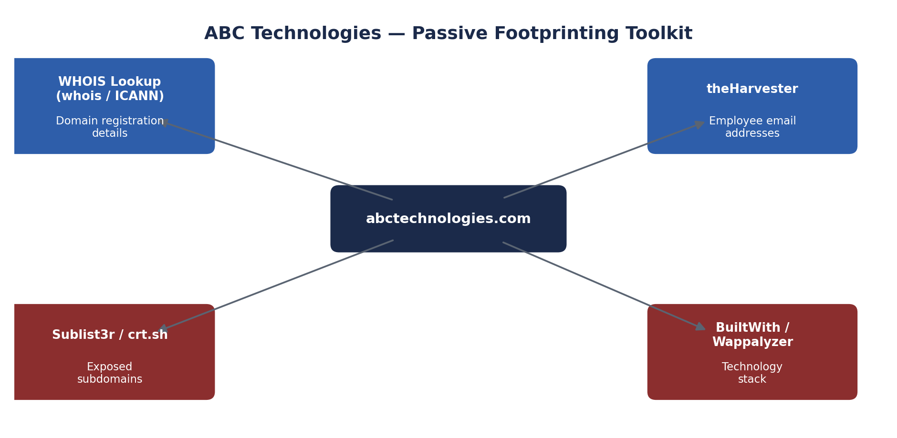
Fig 1.1 — Passive footprinting toolkit mapped to ABC Technologies' public footprint

1.3 Commands Used
# 1. Domain registration details
whois abctechnologies.com
# 2. Employee email addresses
theHarvester -d abctechnologies.com -b google,bing,linkedin -l 300
# 3. Technology stack (via web request headers / online lookup)
whatweb abctechnologies.com
# 4. Exposed subdomains
sublist3r -d abctechnologies.com
curl -s "https://crt.sh/?q=%25.abctechnologies.com&output=json"
Insert your own screenshots here after execution (Screenshot 1 — WHOIS record; Screenshot 2 — theHarvester email list; Screenshot 3 — WhatWeb/BuiltWith tech-stack output; Screenshot 4 — Sublist3r/crt.sh subdomain list).

1.4 How Each Tool Supports Competitive Intelligence
- WHOIS: registrant organisation, registration/expiry dates, and name servers reveal how long the company has operated a domain, hints at rebranding or new subsidiaries, and can expose the hosting/registrar relationships a competitor might infer business scale from.
- theHarvester: harvested addresses reveal naming conventions and which departments have a public-facing presence, useful for understanding organisational structure and estimating headcount/activity in specific teams.
- BuiltWith/Wappalyzer: identifying the CMS, analytics, hosting provider, and frameworks in use shows a competitor (or attacker) what technical stack decisions the company has made and what integrations/vendors it relies on.
- Sublist3r/crt.sh: discovering subdomains such as investor., dev., or shop. can reveal unreleased products, staging/test environments, or business units that are not otherwise publicly announced.

Q2 — DNS Zone Transfer Verification
Scenario: During an authorised penetration test, the analyst suspects the target's DNS server may be misconfigured to permit unauthorised zone transfers (AXFR).

2.1 Command Used to Test for Zone Transfer
# Identify the authoritative name servers first
dig NS target.com
# Attempt a zone transfer against each authoritative server
dig AXFR target.com @ns1.target.com
# Alternative using nslookup
nslookup
> server ns1.target.com
> set type=any
> ls -d target.com
Insert your own screenshot here (Screenshot 1 — dig NS output listing name servers; Screenshot 2 — AXFR attempt result, success or 'Transfer failed').

2.2 DNS Zone Transfer Flow
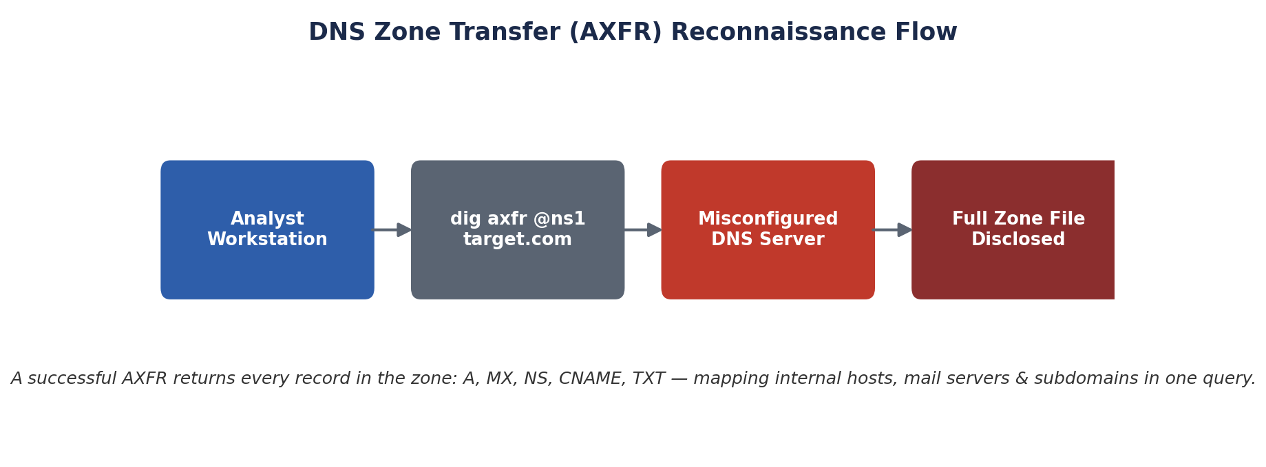
Fig 2.1 — What happens when a DNS server allows an unauthenticated AXFR request

2.3 If the Transfer Succeeds — What It Reveals
Record Type | Information Disclosed | Reconnaissance Value
A / AAAA | IP addresses of every named host in the zone | Maps internal and external hosts directly, skipping brute-force subdomain guessing
MX | Mail server hostnames and priority | Identifies the exact mail infrastructure to target for phishing or relay abuse
NS | All authoritative name servers | Reveals secondary DNS infrastructure and possible additional attack surface
CNAME | Aliases pointing to internal or third-party services | Uncovers hidden services (e.g., dev, vpn, admin panels) not advertised publicly
TXT | SPF records, verification strings, sometimes internal notes | Can leak details about email security policy or third-party integrations
A single successful AXFR essentially hands the analyst (or an attacker) the organisation's entire internal DNS map in one query — equivalent to weeks of manual subdomain enumeration — which is exactly why zone transfers must never be permitted to arbitrary hosts.

2.4 Recommended Fix
- Restrict zone transfers to explicitly whitelisted secondary DNS server IP addresses only (allow-transfer directive in BIND, or equivalent).
- Disable AXFR entirely on public-facing authoritative servers where secondary transfers are not required.
- Use TSIG (transaction signatures) to authenticate any legitimate zone transfer between primary and secondary servers.
- Regularly audit DNS configuration with tools such as dig, dnsrecon, or fierce to confirm transfers are refused.

Q3 — Identifying and Countering a Social Engineering Attack
Scenario: Employees receive an email claiming to be from the IT department, asking them to verify login credentials via a link because of an 'urgent security update.'

3.1 Type of Attack
This is a Phishing attack — specifically a credential-harvesting phishing email using urgency/authority pretexting. Because it targets employees broadly with a generic IT-department pretext (rather than a single, personally-tailored target), it is best classified as bulk/mass phishing; if it were personalised to a specific individual using researched details, it would instead be classified as spear-phishing.

3.2 Red Flags to Check Before Responding
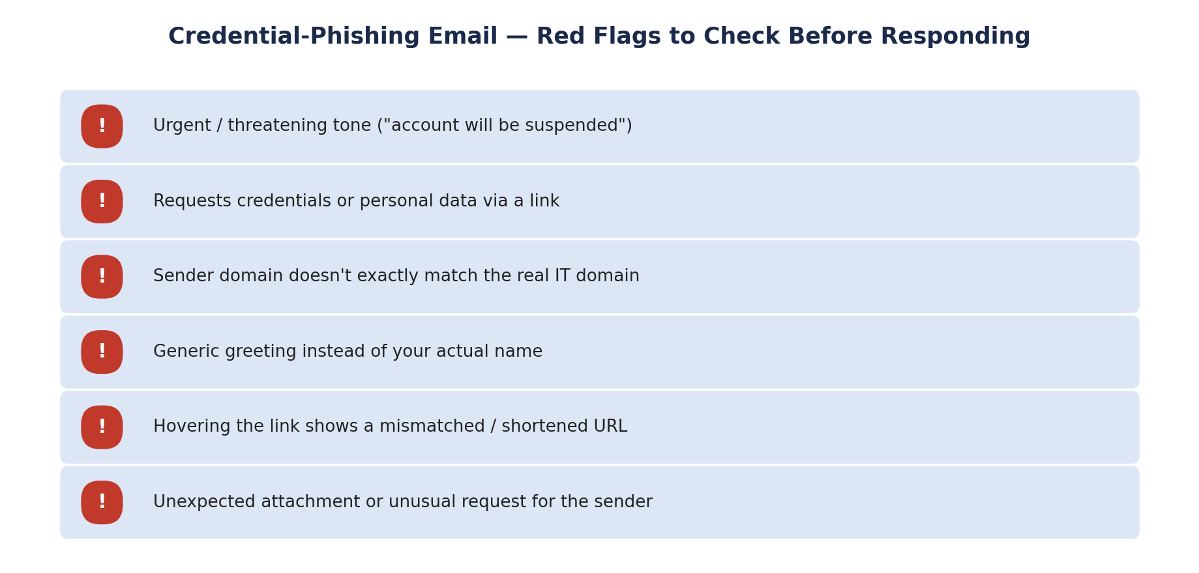
Fig 3.1 — Checklist employees should run through before clicking or entering credentials

3.3 Countermeasures Employees Should Follow
- Do not click the link — instead, navigate to the IT portal directly by typing the known URL or using a saved bookmark.
- Verify the sender's actual email address (not just the display name) and check it matches the organisation's real domain.
- Contact the IT department directly through a known, trusted channel (phone extension, internal chat) to confirm whether the request is genuine.
- Hover over (without clicking) any link to inspect the destination URL for mismatches or suspicious domains.
- Report the email using the organisation's 'Report Phishing' button so security teams can block it and alert other staff.
- Never enter credentials on a page reached via an emailed link — only through the organisation's known login portal.

3.4 How These Actions Prevent Credential Theft
Verifying the sender and avoiding embedded links removes the attacker's core mechanism — a convincing but fake login page designed to capture whatever is typed into it. By confirming requests through an independent, trusted channel, employees short-circuit the urgency/authority pressure the attacker relies on to bypass careful thinking. Reporting the email additionally lets the security team block the sender domain and warn colleagues before anyone else falls for the same message, containing the impact organisation-wide rather than at just the individual level.

